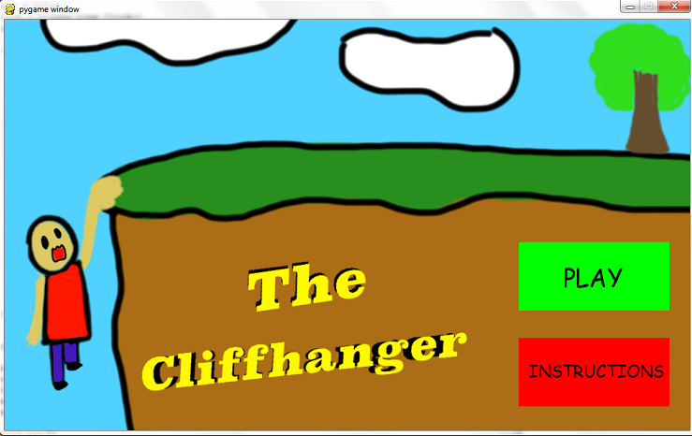**The Cliffhanger Game Manual**

**The Cliffhanger Game Manual**

Welcome to the Cliffhanger. You have been pushed off a cliff by your greatest enemy and are hanging onto the edge. Your enemy will try to hit you with a hammer while you do your best to avoid it while still hanging on to the cliff. The objective of the game is to hang on the cliff for as long as possible.

To play this game, you must have Python 2.7.8 and Pygame 1.9.2. They can be downloaded from python.org and pygame.org. You would also need the game files, which can be downloaded from <http://bit.ly/1cjRC8v>.

Open the program for the game in Python and click “Run Module” under the “Run” tab.

Welcome to the Cliffhanger. You have been pushed off a cliff by your greatest enemy and are hanging onto the edge. Your enemy will try to hit you with a hammer while you do your best to avoid it while still hanging on to the cliff. The objective of the game is to hang on the cliff for as long as possible.

To play this game, you must have Python 2.7 or 3.3 and Pygame 1.9.2. They can be downloaded from python.org and pygame.org. You would also need the game files, which can be downloaded from

In the main menu, click “Play” to begin the game or “Instructions” to review the instructions.

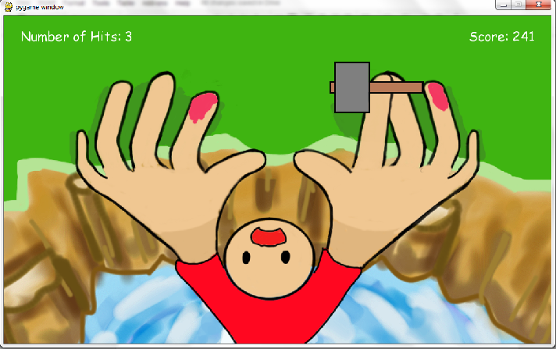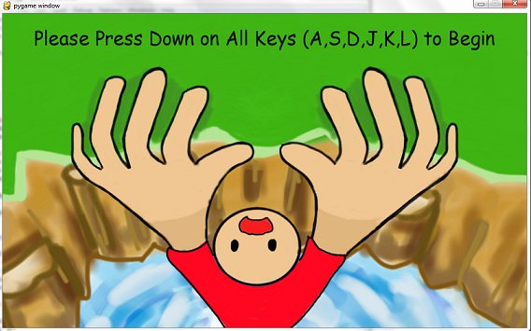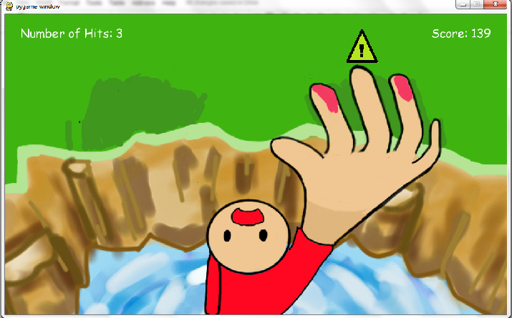

Once the game starts, warning signs will appear above the fingers that are about to be hit by the hammer.

Lift up your finger accordingly to avoid being hit by the hammer.

Once a finger is hit, it will turn pink and become unusable.

**If both hands become unusable, you will fall to your doom.**

If you lift up all your fingers on one hand or all the fingers have been hit, the whole hand becomes unusable.

Place your left hand fingers on the A, S, D keys and your right hand fingers on the J,K,L keys to start the game.